**Practical No : 03**

**Aim** **:** Mongodb Basic Queries With Conditions

1. Create A Sample Collection Orders.

1. Customer (Name)
2. Address ("City", "Country")
3. Paymentmode (Cash,Card, Netbanking,Upi)
4. Email
5. Ordertotal
6. 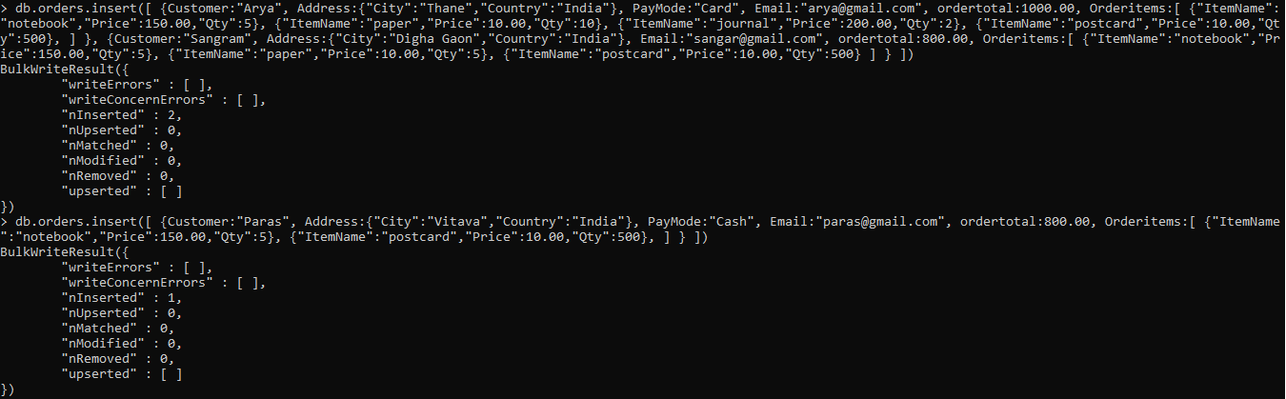Orderitems ("Itemname", "Price", "Qty")

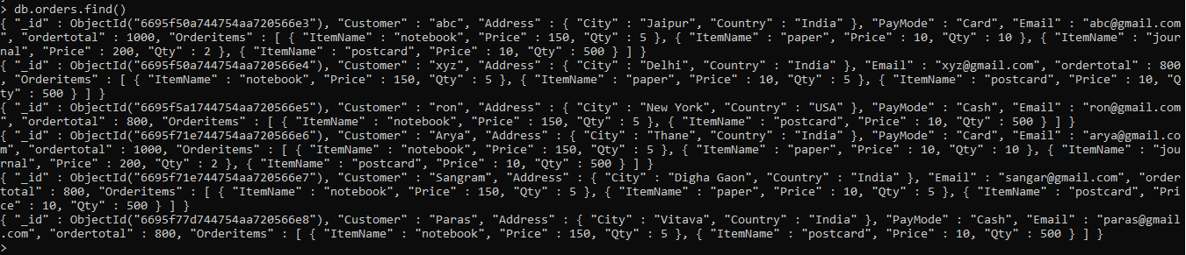2. Write a query to display all documents from MongoDB *orders* collections.

3. Write a query to display the order where *PaymentMode* is 'Card'

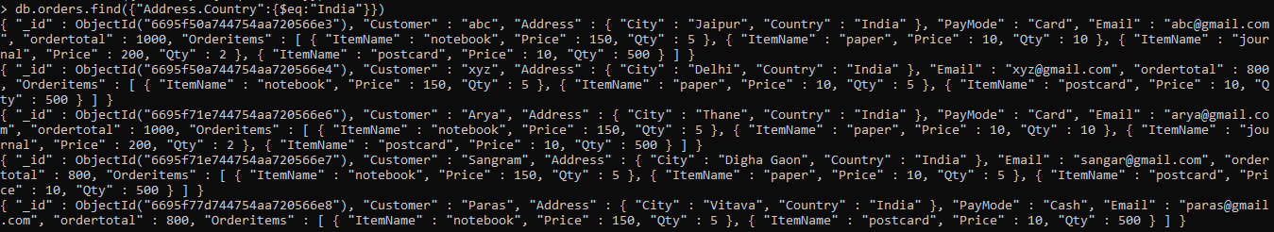4. Write a query to display the order where *Country* is 'India' (you can use a dot notation).

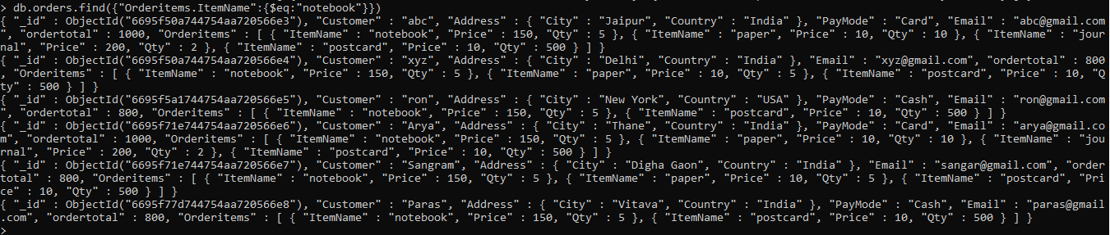5. Write a query to display the order where Item Name is ‘NoteBook’.

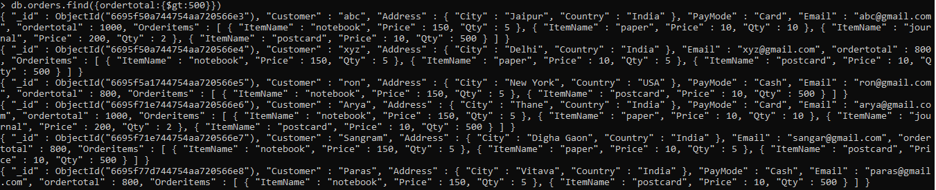6. Write a query to display the documents where *OrderTotal* is greater than 500

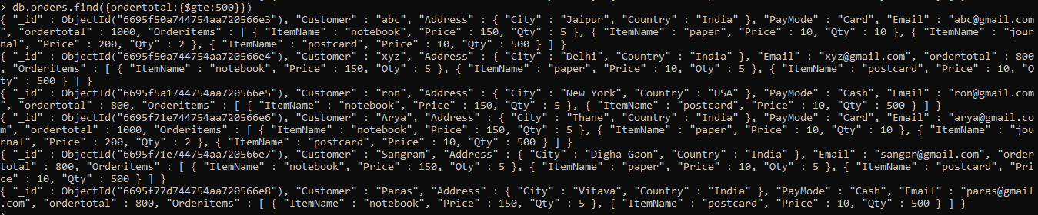7. Write a query to display the documents where *OrderTotal* is greater than or equal to 500.

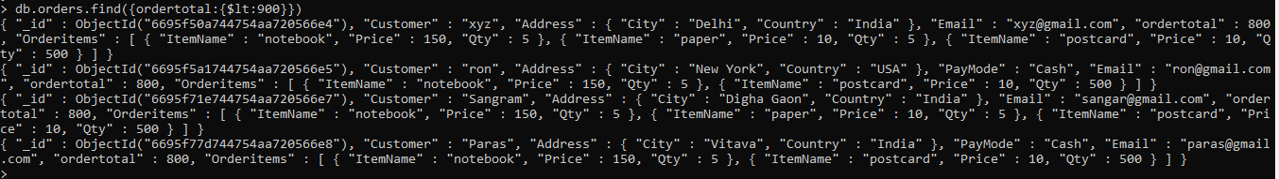8. Write a query to display the documents where *OrderTotal* is less than 900.

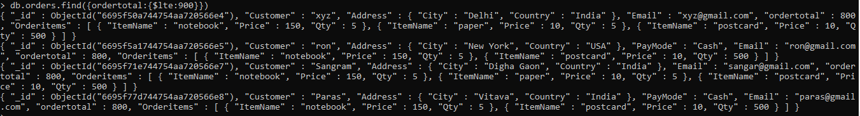9. Write a query to display the documents where *OrderTotal* is less than or equal to 900.

10. Write a query to display the order where *PaymentMode* is not 'Cash'

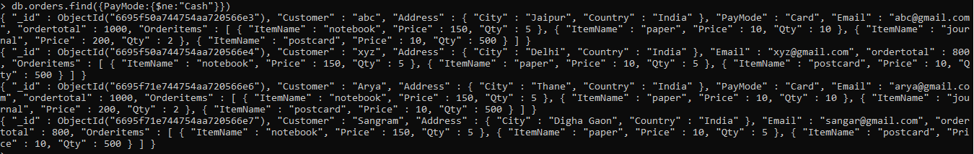

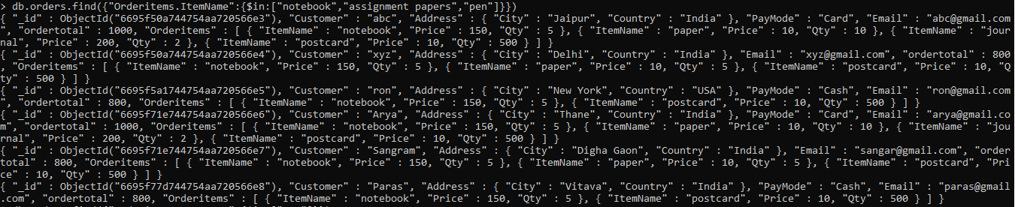11. Write a query to display Write a query to display the order where Item Name is ‘NoteBook’ or ‘Assignment Papers’ or ‘pen’

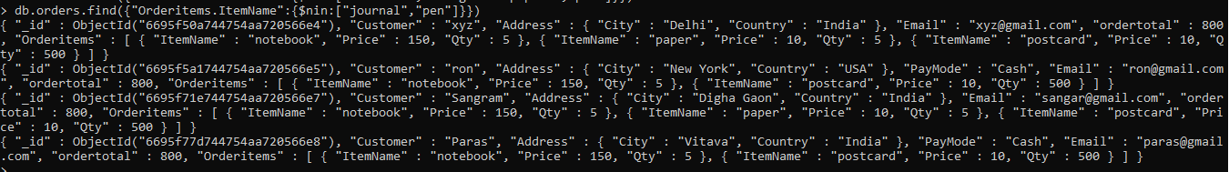12. Write a query to display the order where Item Name is not ‘NoteBook’ or ‘Assignment Papers’

13. Write a query to display the order where city is Mumbai and Item Name is ‘NoteBook’

14. Write a query to display the order where OrderTotal is 600 or price is 200

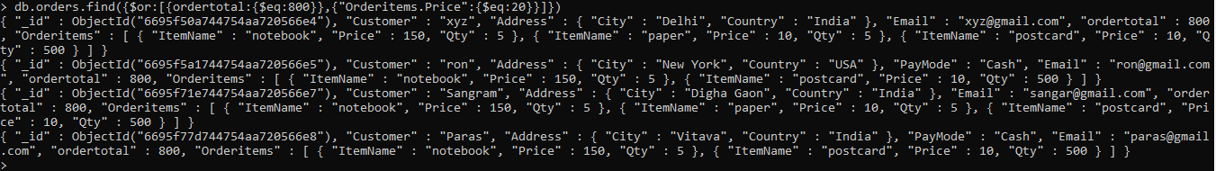

15. Write a query to display the order where OrderTotal is not equal to 600

16. Write a query to display the order where city is not Mumbai and Item Name is not ‘NoteBook’